Arithmetic
# Source: AI Source: Provided by: [Data Path: Persons Table -> ID Column: 1, Name_En Column: Motasem Essam] -> From: [ChatGPT] on [7/11/2026]
Arithmetic is the branch of mathematics that deals with numbers and the basic operations performed on them. It is the foundation of mathematics and is used in everyday activities such as counting, measuring, calculating money, telling time, and solving numerical problems.
Arithmetic is one of the oldest and most fundamental areas of mathematics and serves as the basis for algebra, geometry, calculus, and many other mathematical disciplines.

Definition:
# Source: AI Source: Provided by: [Data Path: Persons Table -> ID Column: 1, Name_En Column: Motasem Essam] -> From: [ChatGPT] on [7/11/2026]
Arithmetic is the branch of mathematics concerned with the study of numbers and the operations of addition, subtraction, multiplication, division, and other numerical computations.

Main Arithmetic Operations
# Source: AI Source: Provided by: [Data Path: Persons Table -> ID Column: 1, Name_En Column: Motasem Essam] -> From: [ChatGPT] on [7/11/2026]
Arithmetic is built on four basic operations.

1. Addition (+)
# Source: AI Source: Provided by: [Data Path: Persons Table -> ID Column: 1, Name_En Column: Motasem Essam] -> From: [ChatGPT] on [7/11/2026]
Addition combines two or more numbers to produce a sum.
Example:
5+3=8

2. Subtraction (−)
# Source: AI Source: Provided by: [Data Path: Persons Table -> ID Column: 1, Name_En Column: Motasem Essam] -> From: [ChatGPT] on [7/11/2026]
Subtraction finds the difference between two numbers.
Example:
9-4=5

3. Multiplication (×)
# Source: AI Source: Provided by: [Data Path: Persons Table -> ID Column: 1, Name_En Column: Motasem Essam] -> From: [ChatGPT] on [7/11/2026]
Multiplication is repeated addition.
Example:
6×4=24

4. Division (÷)
# Source: AI Source: Provided by: [Data Path: Persons Table -> ID Column: 1, Name_En Column: Motasem Essam] -> From: [ChatGPT] on [7/11/2026]
Division splits a number into equal parts.
Example:
20÷5=4

Other Arithmetic Operations
# Source: AI Source: Provided by: [Data Path: Persons Table -> ID Column: 1, Name_En Column: Motasem Essam] -> From: [ChatGPT] on [7/11/2026]
Arithmetic also includes:
- Exponentiation (Powers)
- Square roots
- Absolute value
- Modulus (Remainder)
- Percentage calculations
- Fractions and decimals

Types of Numbers Used in Arithmetic
# Source: AI Source: Provided by: [Data Path: Persons Table -> ID Column: 1, Name_En Column: Motasem Essam] -> From: [ChatGPT] on [7/11/2026]
Arithmetic works with various kinds of numbers, including:
- Natural Numbers
- Whole Numbers
- Integers
- Rational Numbers
- Real Numbers
- Decimal Numbers
- Fractions

Examples
# Source: AI Source: Provided by: [Data Path: Persons Table -> ID Column: 1, Name_En Column: Motasem Essam] -> From: [ChatGPT] on [7/11/2026]
○ Example 1
Addition
15+8=23

○ Example 2
Subtraction
18-7=11

○ Example 3
Multiplication
9×6=54

○ Example 4
Division
36÷9=4

○ Illustration
Suppose you buy
- 3 notebooks costing $5 each.
The total cost is
3×5=15.
Arithmetic allows you to calculate the total amount quickly.

Order of Arithmetic Operations
# Source: AI Source: Provided by: [Data Path: Persons Table -> ID Column: 1, Name_En Column: Motasem Essam] -> From: [ChatGPT] on [7/11/2026]
When an expression contains several operations, they are performed in the following order (PEMDAS/BODMAS):
- Parentheses (Brackets)
- Exponents (Orders)
- Multiplication and Division (left to right)
- Addition and Subtraction (left to right)
Example
8+2×5
First multiply:
2×5=10
Then add:
8+10=18.

Arithmetic Examples in Real Life
# Source: AI Source: Provided by: [Data Path: Persons Table -> ID Column: 1, Name_En Column: Motasem Essam] -> From: [ChatGPT] on [7/11/2026]
1. Shopping
- Adding prices.
- Calculating discounts.
- Computing change.

2. Banking
- Deposits and withdrawals.
- Interest calculations.
- Account balances.

3. Cooking
- Measuring ingredients.
- Doubling or halving recipes.

4. Time Management
- Calculating durations.
- Scheduling appointments.

5. Construction
- Measuring lengths.
- Calculating areas and quantities.

6. Business
- Profit and loss.
- Sales totals.
- Tax calculations.

7. Education
- Calculating grades.
- Computing averages.

8. Sports
- Keeping scores.
- Calculating statistics.

Properties of Arithmetic Operations
# Source: AI Source: Provided by: [Data Path: Persons Table -> ID Column: 1, Name_En Column: Motasem Essam] -> From: [ChatGPT] on [7/11/2026]
Addition
- Commutative
a+b=b+a
- Associative
(a+b)+c=a+(b+c)
- Identity Element
a+0=a

Multiplication
- Commutative
ab=ba

- Associative
(ab)c=a(bc)
- Identity Element
a×1=a
- Distributive
a(b+c)=ab+ac

Applications of Arithmetic
# Source: AI Source: Provided by: [Data Path: Persons Table -> ID Column: 1, Name_En Column: Motasem Essam] -> From: [ChatGPT] on [7/11/2026]
Arithmetic is essential in:
- Mathematics
- Science
- Engineering
- Economics
- Computer Science
- Finance
- Accounting
- Statistics
- Daily Life

History of Arithmetic
# Source: AI Source: Provided by: [Data Path: Persons Table -> ID Column: 1, Name_En Column: Motasem Essam] -> From: [ChatGPT] on [7/11/2026]
The History of Arithmetic is the study of how humans developed methods for counting, calculating, and performing mathematical operations over thousands of years. Arithmetic is the oldest branch of mathematics, dating back to prehistoric times when early humans counted objects using fingers, stones, bones, and tally marks.
As civilizations developed, arithmetic evolved from simple counting into sophisticated systems involving whole numbers, fractions, negative numbers, zero, decimal notation, and advanced computational methods.
Today, arithmetic forms the foundation of mathematics, science, engineering, computer science, economics, and everyday life.

Definition
# Source: AI Source: Provided by: [Data Path: Persons Table -> ID Column: 1, Name_En Column: Motasem Essam] -> From: [ChatGPT] on [7/11/2026]
Arithmetic comes from the Greek word
ἀριθμός (arithmos)
meaning
number.
Arithmetic is the branch of mathematics concerned with:
- Counting
- Representing numbers
- Comparing numbers
- Performing arithmetic operations
- Solving numerical problems

Timeline of the History of Arithmetic

1. Prehistoric Period (Before 3000 BC)
# Source: AI Source: Provided by: [Data Path: Persons Table -> ID Column: 1, Name_En Column: Motasem Essam] -> From: [ChatGPT] on [7/11/2026]
Characteristics
- Counting using fingers.
- Tally marks on bones and sticks.
- Counting stones and pebbles.
- Simple addition and subtraction.
Important Artifact
Ishango Bone
- Approximately 20,000 years old.
- One of the earliest known mathematical tools.
- Contains groups of tally marks believed to represent counting.

2. Ancient Mesopotamia (c. 3000–500 BC)
# Source: AI Source: Provided by: [Data Path: Persons Table -> ID Column: 1, Name_En Column: Motasem Essam] -> From: [ChatGPT] on [7/11/2026]
The Sumerians and Babylonians developed one of the earliest advanced arithmetic systems.
Contributions
- Base-60 (Sexagesimal) numeral system.
- Place value notation.
- Multiplication tables.
- Division tables.
- Square roots.
- Cube roots.
Legacy
The modern:
- 60 seconds per minute
- 60 minutes per hour
- 360° circle
come from Babylonian arithmetic.

3. Ancient Egypt (c. 3000–300 BC)
# Source: AI Source: Provided by: [Data Path: Persons Table -> ID Column: 1, Name_En Column: Motasem Essam] -> From: [ChatGPT] on [7/11/2026]
Egyptians developed practical arithmetic mainly for construction, taxation, and trade.
Contributions
- Decimal number system.
- Unit fractions.
- Addition and subtraction.
- Multiplication by repeated doubling.
- Division by repeated halving.
Famous Document
Rhind Mathematical Papyrus
Contains numerous arithmetic problems and solutions.

4. Ancient Greece (c. 600 BC–300 AD)
# Source: AI Source: Provided by: [Data Path: Persons Table -> ID Column: 1, Name_En Column: Motasem Essam] -> From: [ChatGPT] on [7/11/2026]
Greek mathematicians transformed arithmetic into a theoretical science.
Contributions
- Number theory.
- Prime numbers.
- Greatest Common Divisor.
- Euclidean Algorithm.
- Perfect numbers.
- Mathematical proofs.
Famous Mathematicians
- Pythagoras
- Euclid
- Nicomachus

5. Ancient India (c. 500 BC–1200 AD)
# Source: AI Source: Provided by: [Data Path: Persons Table -> ID Column: 1, Name_En Column: Motasem Essam] -> From: [ChatGPT] on [7/11/2026]
India made one of the greatest contributions to arithmetic.
Contributions
- Hindu-Arabic numeral system.
- Decimal place value.
- The number zero.
- Negative numbers.
- Arithmetic algorithms.
Famous Mathematicians
- Aryabhata
- Brahmagupta
- Bhāskara II

6. Ancient China (c. 500 BC–1400 AD)
# Source: AI Source: Provided by: [Data Path: Persons Table -> ID Column: 1, Name_En Column: Motasem Essam] -> From: [ChatGPT] on [7/11/2026]
Chinese mathematics focused on efficient computation.
Contributions
- Counting rods.
- Abacus.
- Fractions.
- Linear equations.
- Negative numbers.
- Square roots.
Famous Book
The Nine Chapters on the Mathematical Art

7. Islamic Golden Age (8th–14th Century)
# Source: AI Source: Provided by: [Data Path: Persons Table -> ID Column: 1, Name_En Column: Motasem Essam] -> From: [ChatGPT] on [7/11/2026]
Islamic scholars preserved and expanded Greek and Indian arithmetic.
Contributions
- Algebra and arithmetic.
- Decimal fractions.
- Algorithms.
- Arithmetic with large numbers.
- Introduction of Hindu-Arabic numerals to Europe.
Famous Mathematicians
- Al-Khwarizmi
- Al-Karaji
- Omar Khayyam
The word algorithm comes from the Latinized name of Al-Khwarizmi.

8. Medieval Europe (5th–15th Century)
# Source: AI Source: Provided by: [Data Path: Persons Table -> ID Column: 1, Name_En Column: Motasem Essam] -> From: [ChatGPT] on [7/11/2026]
European mathematics gradually adopted Hindu-Arabic numerals.
Contributions
- Replacement of Roman numerals.
- Commercial arithmetic.
- Merchant mathematics.
- Arithmetic textbooks.
Famous Mathematician
Leonardo Fibonacci.

9. Renaissance (15th–17th Century)
# Source: AI Source: Provided by: [Data Path: Persons Table -> ID Column: 1, Name_En Column: Motasem Essam] -> From: [ChatGPT] on [7/11/2026]
Arithmetic expanded with commerce, navigation, and science.
Contributions
- Decimal fractions.
- Logarithms.
- Improved notation.
- Scientific calculations.
Famous Mathematicians
- Simon Stevin
- John Napier

10. Modern Arithmetic (18th Century–Present)
# Source: AI Source: Provided by: [Data Path: Persons Table -> ID Column: 1, Name_En Column: Motasem Essam] -> From: [ChatGPT] on [7/11/2026]
Arithmetic became a formal mathematical discipline.
Contributions
- Abstract number systems.
- Computational arithmetic.
- Computer arithmetic.
- Floating-point arithmetic.
- Arbitrary-precision arithmetic.
- Cryptographic arithmetic.

Evolution of Number Systems
# Source: AI Source: Provided by: [Data Path: Persons Table -> ID Column: 1, Name_En Column: Motasem Essam] -> From: [ChatGPT] on [7/11/2026]
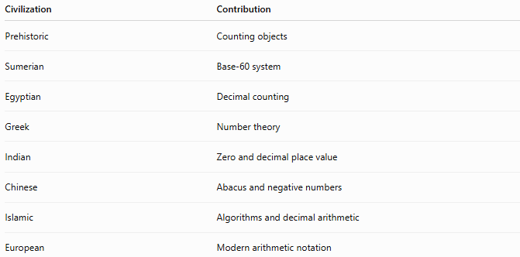
Civilization | Contribution
Prehistoric | Counting objects
Sumerian | Base-60 system
Egyptian | Decimal counting
Greek | Number theory
Indian | Zero and decimal place value
Chinese | Abacus and negative numbers
Islamic | Algorithms and decimal arithmetic
European | Modern arithmetic notation

Evolution of Arithmetic Operations
# Source: AI Source: Provided by: [Data Path: Persons Table -> ID Column: 1, Name_En Column: Motasem Essam] -> From: [ChatGPT] on [7/11/2026]
Counting
↓
Addition
↓
Subtraction
↓
Multiplication
↓
Division
↓
Fractions
↓
Negative Numbers
↓
Decimals
↓
Powers
↓
Roots
↓
Logarithms
↓
Modular Arithmetic
↓
Computer Arithmetic

Important Historical Milestones
# Source: AI Source: Provided by: [Data Path: Persons Table -> ID Column: 1, Name_En Column: Motasem Essam] -> From: [ChatGPT] on [7/11/2026]
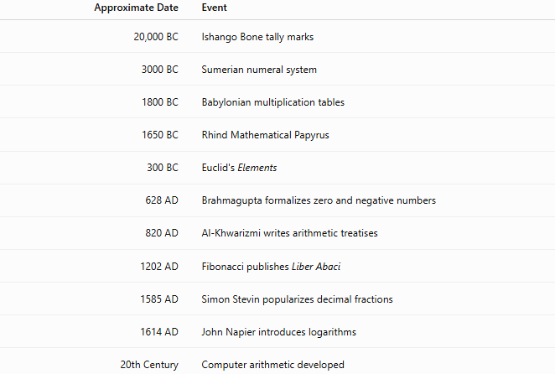
Approximate Date | Event
20,000 BC | Ishango Bone tally marks
3000 BC | Sumerian numeral system
1800 BC | Babylonian multiplication tables
1650 BC | Rhind Mathematical Papyrus
300 BC | Euclid's Elements
628 AD | Brahmagupta formalizes zero and negative numbers
820 AD | Al-Khwarizmi writes arithmetic treatises
1202 AD | Fibonacci publishes Liber Abaci
1585 AD | Simon Stevin popularizes decimal fractions
1614 AD | John Napier introduces logarithms
20th Century | Computer arithmetic developed

Famous Mathematicians in Arithmetic
# Source: AI Source: Provided by: [Data Path: Persons Table -> ID Column: 1, Name_En Column: Motasem Essam] -> From: [ChatGPT] on [7/11/2026]
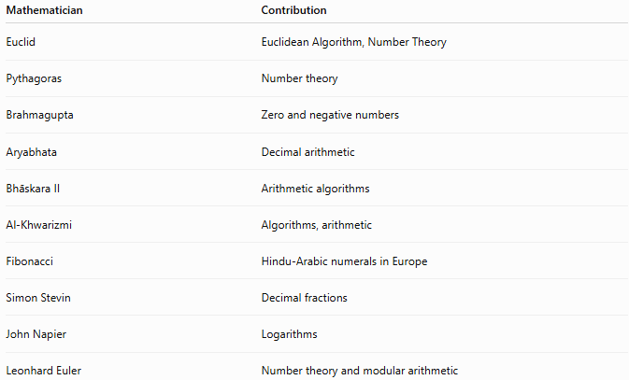
Mathematician | Contribution
Euclid | Euclidean Algorithm, Number Theory
Pythagoras | Number theory
Brahmagupta | Zero and negative numbers
Aryabhata | Decimal arithmetic
Bhāskara II | Arithmetic algorithms
Al-Khwarizmi | Algorithms, arithmetic
Fibonacci | Hindu-Arabic numerals in Europe
Simon Stevin | Decimal fractions
John Napier | Logarithms
Leonhard Euler | Number theory and modular arithmetic

Real-Life Impact
# Source: AI Source: Provided by: [Data Path: Persons Table -> ID Column: 1, Name_En Column: Motasem Essam] -> From: [ChatGPT] on [7/11/2026]
The historical development of arithmetic made possible:
- Commerce and trade
- Banking and finance
- Taxation
- Engineering
- Architecture
- Astronomy
- Navigation
- Computer science
- Cryptography
- Artificial intelligence

Interesting Facts
# Source: AI Source: Provided by: [Data Path: Persons Table -> ID Column: 1, Name_En Column: Motasem Essam] -> From: [ChatGPT] on [7/11/2026]
- Arithmetic is the oldest branch of mathematics.
- The concept of zero originated in ancient India.
- Roman numerals have no symbol for zero.
- The word algorithm comes from Al-Khwarizmi.
- The Babylonian base-60 system is still used for measuring time and angles.
- Modern computers perform billions of arithmetic operations every second.

Key Points
# Source: AI Source: Provided by: [Data Path: Persons Table -> ID Column: 1, Name_En Column: Motasem Essam] -> From: [ChatGPT] on [7/11/2026]
- Arithmetic began with simple counting in prehistoric times.
- Every major civilization contributed to its development.
- India introduced zero and the decimal place-value system.
- Islamic scholars spread Hindu-Arabic numerals and arithmetic methods.
- Arithmetic evolved into modern computational mathematics.
- Today, arithmetic underpins nearly every scientific and technological field.

History of Arithmetic vs. History of Number Theory
# Source: AI Source: Provided by: [Data Path: Persons Table -> ID Column: 1, Name_En Column: Motasem Essam] -> From: [ChatGPT] on [7/11/2026]
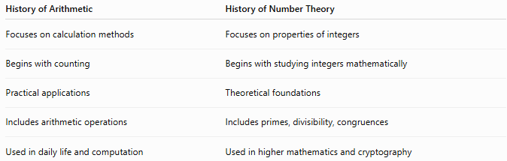
History of Arithmetic | History of Number Theory
Focuses on calculation methods | Focuses on properties of integers
Begins with counting | Begins with studying integers mathematically
Practical applications | Theoretical foundations
Includes arithmetic operations | Includes primes, divisibility, congruences
Used in daily life and computation | Used in higher mathematics and cryptography

Conclusion
# Source: AI Source: Provided by: [Data Path: Persons Table -> ID Column: 1, Name_En Column: Motasem Essam] -> From: [ChatGPT] on [7/11/2026]
The History of Arithmetic traces humanity's journey from simple counting with tally marks and fingers to the sophisticated numerical systems used in modern science and computing. Contributions from the Mesopotamians, Egyptians, Greeks, Indians, Chinese, Islamic scholars, and Europeans transformed arithmetic into the universal language of calculation. Today, arithmetic remains the foundation of mathematics and supports countless applications in technology, engineering, finance, cryptography, and everyday life.

Conclusion
# Source: AI Source: Provided by: [Data Path: Persons Table -> ID Column: 1, Name_En Column: Motasem Essam] -> From: [ChatGPT] on [7/11/2026]
Arithmetic is the branch of mathematics that studies numbers and the basic operations performed on them. It provides the foundation for solving numerical problems and supports nearly every area of mathematics and everyday life. Mastery of arithmetic is essential for understanding more advanced mathematical concepts.

Summary Comparison
# Source: AI Source: Provided by: [Data Path: Persons Table -> ID Column: 1, Name_En Column: Motasem Essam] -> From: [ChatGPT] on [7/11/2026]
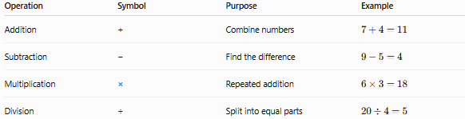
Operation | Symbol | Purpose | Example
Addition | + | Combine numbers | (7+4=11)
Subtraction | − | Find the difference | (9-5=4)
Multiplication | × | Repeated addition | (6\times3=18)
Division | ÷ | Split into equal parts | (20\div4=5)
Memory Tip
Remember the four basic arithmetic operations:
- + Add
- − Subtract
- × Multiply
- ÷ Divide
A simple phrase to remember them is:
"Add, Subtract, Multiply, Divide" (ASMD)
These four operations form the foundation of arithmetic and are used in almost every mathematical calculation.

